# TensionCamApp: Developer Manual

**Latest revision:** 2013-05-20

A quick-start guide and overlook of the TensionCamApp Android application designed for G-coder Systems AB.

## Getting started

git clone git:// github.com/lisarythenlarsson/TensionCamApp

## Dependencies

* Android SDK
* An actual (preferred) or virtual Android device
* Java XX XX (6 SE) development environment

## Android SDK targets

* Minimum SDK: **16**
* Target SDK: **16**

(SDK targets are motivated in *Project Plan*)

## License

## Building and installing

A build.xml is included in the root directory which may be used for building the project. The default output directory is bin in the project root. By default, Eclipse is set to build automatically. To build the project manually, go to *Project* in the menu bar.

To install the TensionCamApp on an Android device, the project has to be run as an Android Application in Eclipse. In order for this to work, the device has to be connected via Android Debug Bridge (ADB).

To uninstall the TensionCamApp on an Android device, standard procedures should be followed. I.e. using the device’s default tool for app-removal is recommended.

## Release procedure

This section describes the steps taken before every release of the TensionCam Application.

### Requirements

To build an application package in release mode, it needs to be signed with a certificate. Refer to this Android guide on signing applications for release: <http://developer.android.com/tools/publishing/app-signing.html>. Releases will be built, signed and compiled Eclipse ADT. Access to a keystore is necessary for signing application. The keystore path is TensionCamApp/certs/realese.keystore

### Building a release package

Use Eclipse ADT to compile and sign an apk-file for release:

1. Select the project in the Package Explorer and select **File > Export**.
2. Open the Android folder, select Export Android Application, and click **Next**.

The Export Android Application wizard now starts, which will guide you through the process of signing your application. When signing you will need to provide the key alias and password stored in keystore.

1. Complete the Export Wizard and your application will be compiled, signed, aligned, and ready for distribution.

### Organizing the distribution directory

After having built a release package, it should be organized in the distribution directory: **dist** in root direvtory.

1. Create a new directory in dist named with the version number. Examples:

a. v0.1

b. v0.2

.

.

.

2. Move the TensionCamApp.apk package from the bin directory to the newly created release directory

3. Rename the application package to TensionCamApp-<version>.apk. Examples:

a. TensionCamApp-v0.1.apk

b. TensionCamApp-v0.2.apk

### Release requirements

Every release’s directory include the following:

* An application package (see above).
* A release notes document with the following headings (if applicable):
  + New features
  + Changed features
  + Removed features
  + Known bugs
  + Coming features
* A test report document.

## Tests

Automatic tests are included in a separate project embedded within the application project which is called TensionCamTesterTest. To run the included tests

## Architecture

The application code resides in different packages and over all can the architecture be divided in three parts

* Spring MVC project (Analyze) for web server (package net.codejava.analyze)
* Android application project (TensionCamApp) (packages for activities, utils, views, controllers)
* External software (analyzing program) provided by the client

The reasons for using a web server are several. The main reason is less redundancy since there is no need for each device (cell phone) to carry the analyze program. This minimizes the storage need for the application. It also enables the analyzing program to be run on a more powerful machine.

### Android application project

**Packages:**

activitis, utils, views, controllers

**External libraries:**

HttpClient 4.2.5

HttpCore 4.2.4

**Motivation for libraries:**

Enables connecting to and communicating with the web server through POST request.

Helpers are provided in the utils package. The controller consits of a class that also function as a model

### Spring MVC Project

**Packages:**

net.codejava.analyze

**External libraries:**

Commons FileUpload 1.3

**Motivation for libraries:**

Enables the client to send picture (file) to the web server through a POST request whit multipart/form-data, in this case the picture.

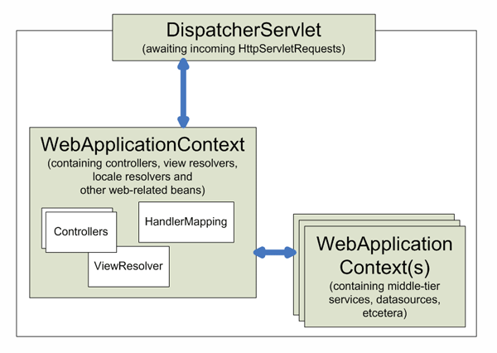

Figure 1. Context hierarchy in Spring Web MVC

*Source:* http://static.springsource.org/spring/docs/2.0.x/reference/mvc.html

### Overview

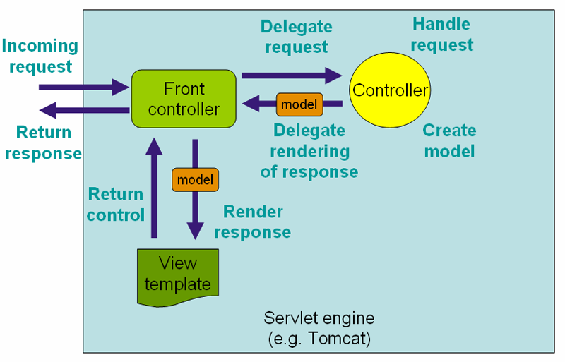

**TensionCamApp-project**

doInBackground(String... params)

Figure 2. The requesting processing in Spring Web MVC.

*Source:* <http://static.springsource.org/spring/docs/2.0.x/reference/mvc.html>

The android application project communicates with the servlet engine through an incoming request in the doInBackground(String... params) –method in SendTask.class . The communication is done in a seperate thread from application’s main thread. doInBackground(String... params) –method also receives the returns method and calls onPostExecute(String result) which sets the result in the application.